<직접 풀어보기 6-3>

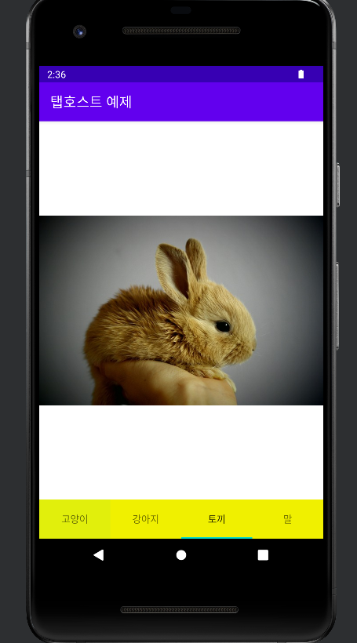

<?xml version="1.0" encoding="utf-8"?>  
<TabHost xmlns:android="http://schemas.android.com/apk/res/android"  
 android:id="@+id/TabHost"  
 android:layout_width="match_parent"  
 android:layout_height="match_parent">  
  
 <LinearLayout  
 android:layout_width="match_parent"  
 android:layout_height="match_parent"  
 android:orientation="vertical" >  
 <FrameLayout  
 android:id="@android:id/tabcontent"  
 android:layout_width="match_parent"  
 android:layout_height="match_parent"  
 android:layout_weight="1" >  
 <ImageView  
 android:id="@+id/고양이"  
 android:layout_width="match_parent"  
 android:layout_height="match_parent"  
 android:src="@drawable/cat">  
 </ImageView>  
  
 <ImageView  
 android:id="@+id/강아지"  
 android:layout_width="match_parent"  
 android:layout_height="match_parent"  
 android:src="@drawable/dog">  
 </ImageView>  
  
 <ImageView  
 android:id="@+id/말"  
 android:layout_width="match_parent"  
 android:layout_height="match_parent"  
 android:src="@drawable/horse">  
 </ImageView>  
  
 <ImageView  
 android:id="@+id/토끼"  
 android:layout_width="match_parent"  
 android:layout_height="match_parent"  
 android:src="@drawable/rabbit">  
 </ImageView>  
 </FrameLayout>  
  
 <TabWidget  
 android:id="@android:id/tabs"  
 android:layout_width="match_parent"  
 android:layout_height="wrap_content"  
 android:background="#f0f000">  
 </TabWidget>  
 </LinearLayout>  
</TabHost>

package com.example.assis6_3;  
  
import androidx.appcompat.app.AppCompatActivity;  
  
import android.os.Bundle;  
import android.widget.TabHost;  
  
public class MainActivity extends AppCompatActivity {  
  
 @Override  
 protected void onCreate(Bundle savedInstanceState) {  
 super.onCreate(savedInstanceState);  
 setContentView(R.layout.*activity_main*);  
  
 setTitle("탭호스트 예제");  
  
 TabHost tabHost = findViewById(R.id.*TabHost*);  
 tabHost.setup();  
  
 TabHost.TabSpec tabSpecCat = tabHost.newTabSpec("CAT").setIndicator("고양이");  
 tabSpecCat.setContent(R.id.*고양이*);  
 tabHost.addTab(tabSpecCat);  
  
 TabHost.TabSpec tabSpecDog = tabHost.newTabSpec("DOG").setIndicator("강아지");  
 tabSpecDog.setContent(R.id.*강아지*);  
 tabHost.addTab(tabSpecDog);  
  
 TabHost.TabSpec tabSpecRabbit = tabHost.newTabSpec("RABBIT").setIndicator("토끼");  
 tabSpecRabbit.setContent(R.id.*토끼*);  
 tabHost.addTab(tabSpecRabbit);  
  
 TabHost.TabSpec tabSpecHorse = tabHost.newTabSpec("HORSE").setIndicator("말");  
 tabSpecHorse.setContent(R.id.*말*);  
 tabHost.addTab(tabSpecHorse);  
  
 tabHost.setCurrentTab(0);  
 }  
}

<예제 6-19 ~ 21>

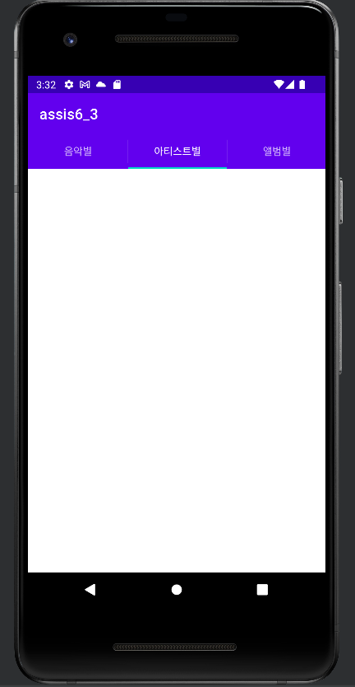

package com.example.assis6_3;  
  
import androidx.appcompat.app.ActionBar;  
import androidx.appcompat.app.AppCompatActivity;  
import androidx.fragment.app.Fragment;  
import androidx.fragment.app.FragmentActivity;  
import androidx.fragment.app.FragmentTransaction;  
  
import android.graphics.Color;  
import android.os.Bundle;  
import android.view.LayoutInflater;  
import android.view.View;  
import android.view.ViewGroup;  
import android.widget.LinearLayout;  
  
import com.google.android.material.tabs.TabLayout;  
  
import java.nio.BufferUnderflowException;  
  
public class MainActivity extends AppCompatActivity implements ActionBar.TabListener {  
 ActionBar.Tab tabSong, tabArtist, tabAlbum;  
  
 MyTabFragment myFrags[] = new MyTabFragment[3];  
  
 public void onTabSelected(TabLayout.Tab tab, FragmentTransaction ft){  
 MyTabFragment myTabFrag = null;  
  
 if(myFrags[tab.getPosition()]==null){  
 myTabFrag = new MyTabFragment();  
 Bundle data = new Bundle();  
 data.putString("tabName", tab.getText().toString());  
 myTabFrag.setArguments(data);  
 myFrags[tab.getPosition()] = myTabFrag;  
 }  
 else  
 myTabFrag = myFrags[tab.getPosition()];  
  
 ft.replace(android.R.id.*content*, myTabFrag);  
 }  
  
 @Override  
 protected void onCreate(Bundle savedInstanceState) {  
 super.onCreate(savedInstanceState);  
 ActionBar bar = getSupportActionBar();  
 bar.setNavigationMode(ActionBar.*NAVIGATION_MODE_TABS*);  
  
 tabSong = bar.newTab();  
 tabSong.setText("음악별");  
 tabSong.setTabListener(this);  
 bar.addTab(tabSong);  
  
 tabArtist = bar.newTab();  
 tabArtist.setText("아티스트별");  
 tabArtist.setTabListener(this);  
 bar.addTab(tabArtist);  
  
 tabAlbum = bar.newTab();  
 tabAlbum.setText("앨범별");  
 tabAlbum.setTabListener(this);  
 bar.addTab(tabAlbum);  
 }  
  
 @Override  
 public void onTabSelected(ActionBar.Tab tab, FragmentTransaction ft) {  
 // 코드를 여기에 추가하세요.  
 }  
  
 @Override  
 public void onTabUnselected(ActionBar.Tab tab, FragmentTransaction ft) {  
 // 코드를 여기에 추가하세요.  
 }  
  
 @Override  
 public void onTabReselected(ActionBar.Tab tab, FragmentTransaction ft) {  
 // 코드를 여기에 추가하세요.  
 }  
  
 public static class MyTabFragment extends androidx.fragment.app.Fragment {  
 String tabName;  
  
 public void onCreate(Bundle savedInstanceState){  
 super.onCreate(savedInstanceState);  
 Bundle data = getArguments();  
 tabName = data.getString("tabName");  
 }  
  
 public View onCreateView(LayoutInflater inflater, ViewGroup container, Bundle savedInstance){  
 LinearLayout.LayoutParams params = new LinearLayout.LayoutParams(LinearLayout.LayoutParams.*MATCH_PARENT*, LinearLayout.LayoutParams.*MATCH_PARENT*);  
 LinearLayout baseLayout = new LinearLayout(super.getActivity());  
 baseLayout.setOrientation(LinearLayout.*VERTICAL*);  
 baseLayout.setLayoutParams(params);  
  
 if(tabName.equals("음악별")) baseLayout.setBackgroundColor(Color.*RED*);  
 if(tabName.equals("아티스트별")) baseLayout.setBackgroundColor(Color.*GREEN*);  
 if(tabName.equals("앨범별")) baseLayout.setBackgroundColor(Color.*BLUE*);  
  
 return baseLayout;  
 }  
  
 }  
}